

IT342-G4 SYSTEMS INTEGRATION AND

ARCHITECTURE 1

FUNCTIONAL REQUIREMENTS SPECIFICATION (FRS)

Project Title: Mini App – User Registration & Authentication System Prepared By: Myron Deandre G. Alia
Date of Submission: 2/3/2026 Version: 1.0

Table of Contents
1. 3

1.1. 3
1.2. 3
1.3. 3
2. 3
2.1. 3
2.2. 4
2.3. 4
2.4. 4
3. 4
3.1. 4
3.2. 5
4. 5
5. 6
5.1. 6
5.2. 6
5.3. 7
5.4. 8
5.5. 9
6. 9

Introduction
  - Purpose
This document describes the functional requirements for the User Authentication System. It is intended for developers, system designers, and instructors to understand how the system should behave before implementation. The system will allow users to register, log in, access protected pages, and log out securely.
  - Scope
The system provides basic authentication features including account registration, login verification, access control to protected pages, and logout functionality. The system does not include advanced features such as email verification, password recovery, or multi- factor authentication. The system will be used as a learning project for implementing frontend and backend integration.
  - Definitions, Acronyms, and Abbreviations

Term | Meaning
UI | User Interface
API | Application Program Interface
DB | Database
Auth | Authentication
JWT | JSON Web Token

Overall Description
  - System Perspective
The system is a web-based application composed of a React frontend, a Spring Boot backend API, and a relational database. The frontend communicates with the backend through REST APIs, while the backend handles business logic and database interactions.

  - User Classes and Characteristics

User Type | Description
Guest User | Not logged in. Can register and log in.
Authenticated User | Logged-in user who can access protected pages like dashboard and profile.

  - Operating Environment
Frontend: React JS (Web Browser) Backend: Spring Boot (Java) Database: Firebase
Development Tools: draw.io

  - Assumptions and Dependencies
Users have internet access.
Backend server is running and accessible. Database server is available.
Users will provide valid information during registration.

System Features and Functional Requirements
Describe each major feature of the system and its functional requirements.
  - Feature 1: User Registration
Description: Allows a guest user to create an account by providing required information.
Functional Requirements:
    - The system shall allow users to input name, email, and password.
    - The system shall validate that the email is unique.
    - The system shall encrypt the password before saving it.
    - The system shall store the user in the database.
    - The system shall display a success or error message.

  - Feature 2: User Login
Description: Allows a registered user to log in using email and password. Functional Requirements:
    - The system shall allow users to enter email and password.
    - The system shall verify credentials with the database.
    - The system shall generate an authentication token upon successful login.
    - The system shall deny access if credentials are incorrect.
    - The system shall redirect the user to the dashboard after login.

  - Feature 3: View Profile/Dashboard
Description: Allows authenticated users to access protected pages. Functional Requirements:
    - The system shall allow only logged-in users to access protected pages.
    - The system shall display user information on the dashboard.
    - The system shall block access if no valid token/session exists.

  - Feature 4: Logout
Description: Allows authenticated users to securely log out..\ Functional Requirements:
    - The system shall provide a logout option.
    - The system shall invalidate the authentication token/session.
    - The system shall redirect the user to the login page.
    - The system shall prevent access to protected pages after logout.

Non-Functional Requirements

Category | Requirement
Performance | System should respond within 2 seconds.
Security | Passwords must be encrypted. Protected routes require authentication.
Usability | Interface should be simple and easy to navigate.
Reliability | System should be available 95% of the time.
Scalability | System should support increasing number of users.

- System Models (Diagrams)
Insert the necessary diagrams for the system:
  - ERD
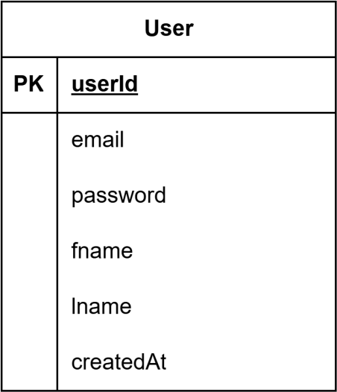

  - Use Case Diagram
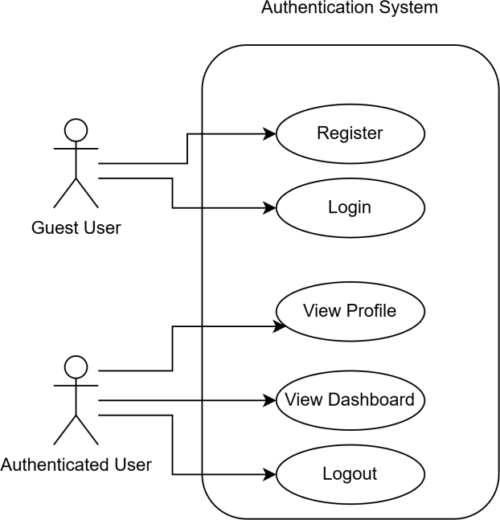

  - Activity Diagram
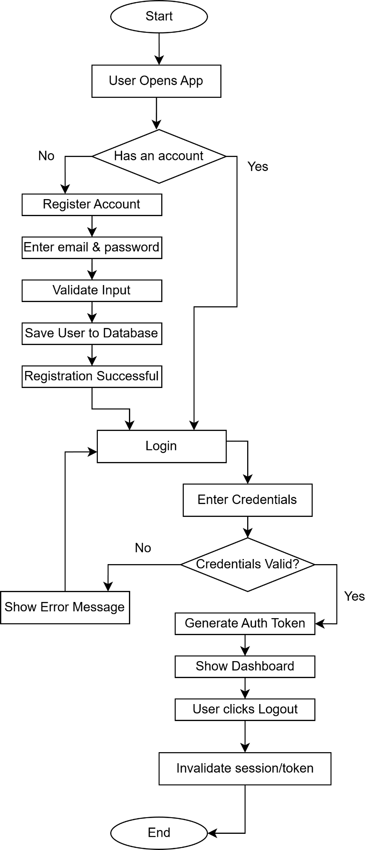

  - Class Diagram
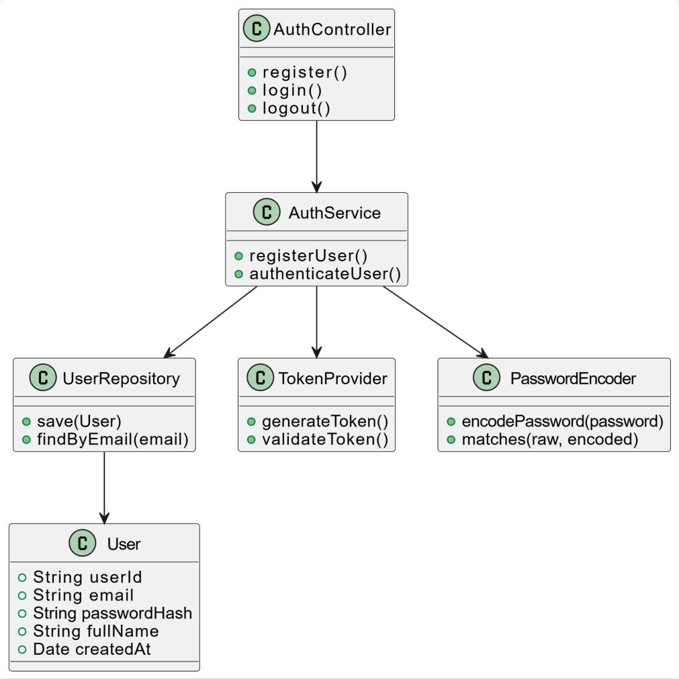

  - Sequence Diagram
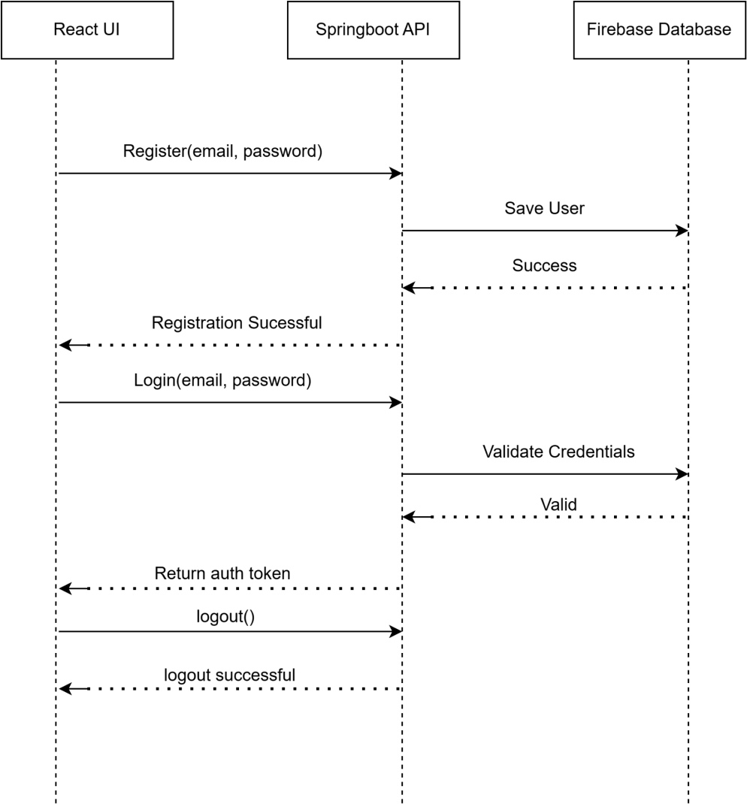

Appendices
Include any additional information, references, or support materials.

- Final UI Screenshots
Login
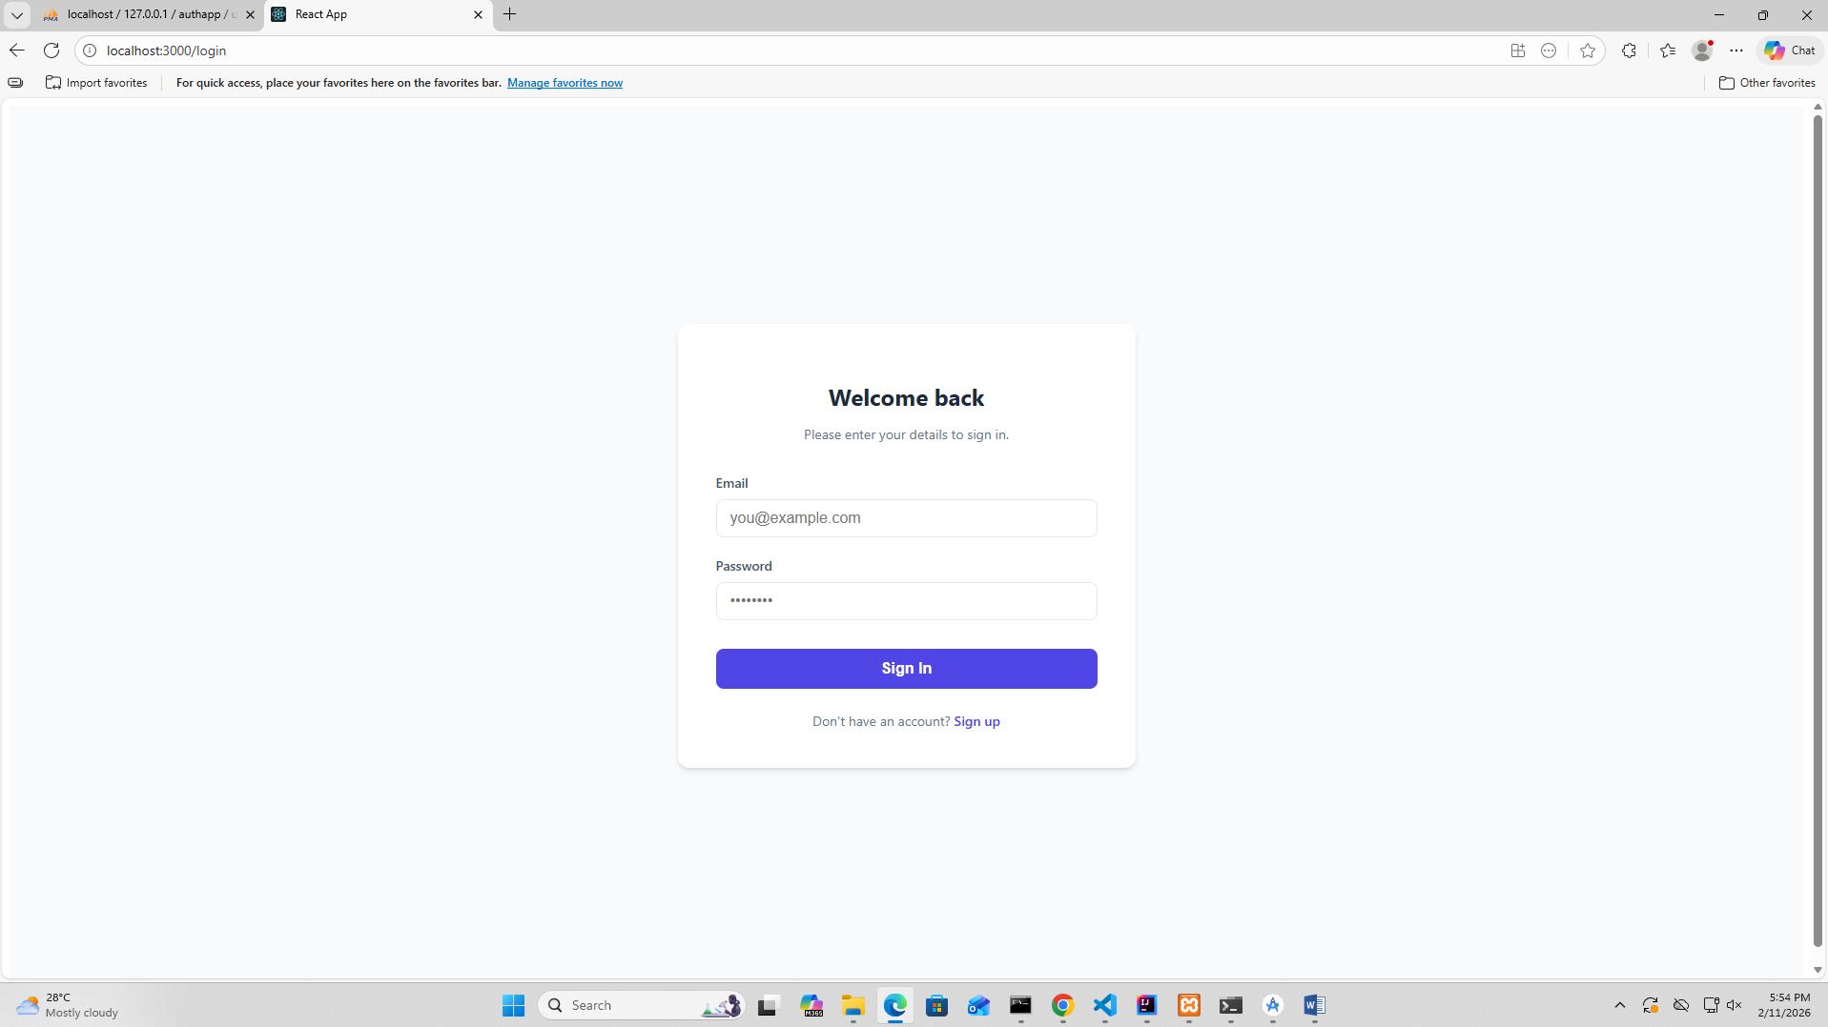
Register
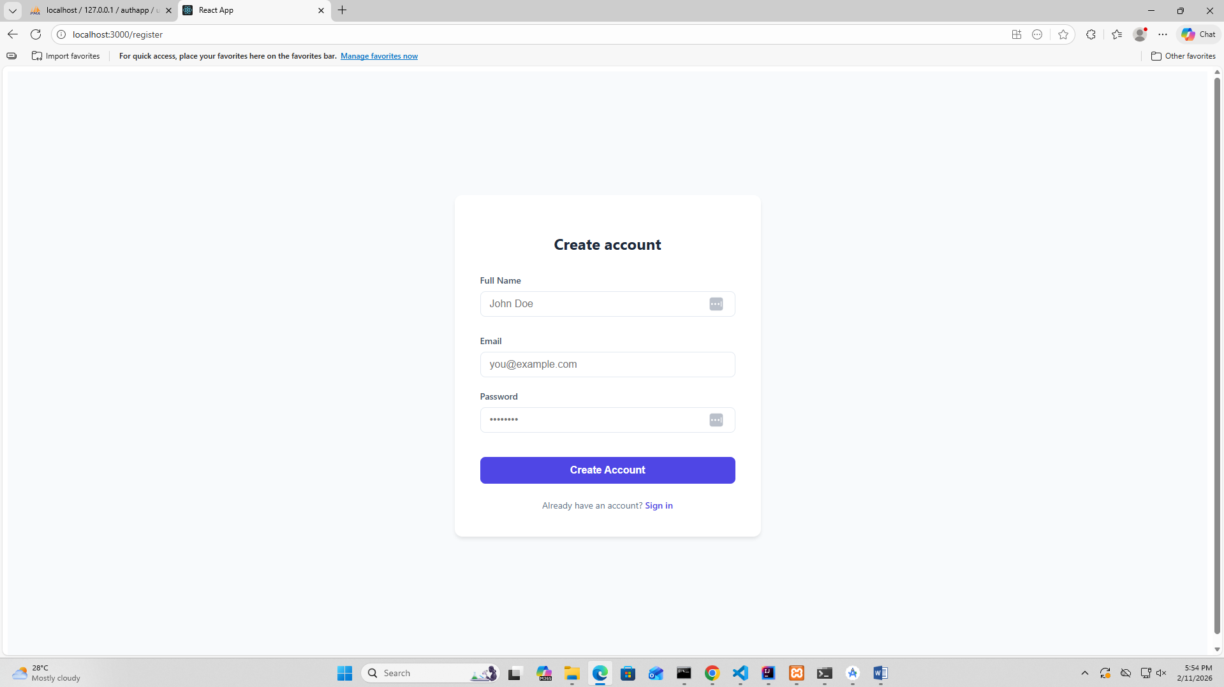

Dashboard
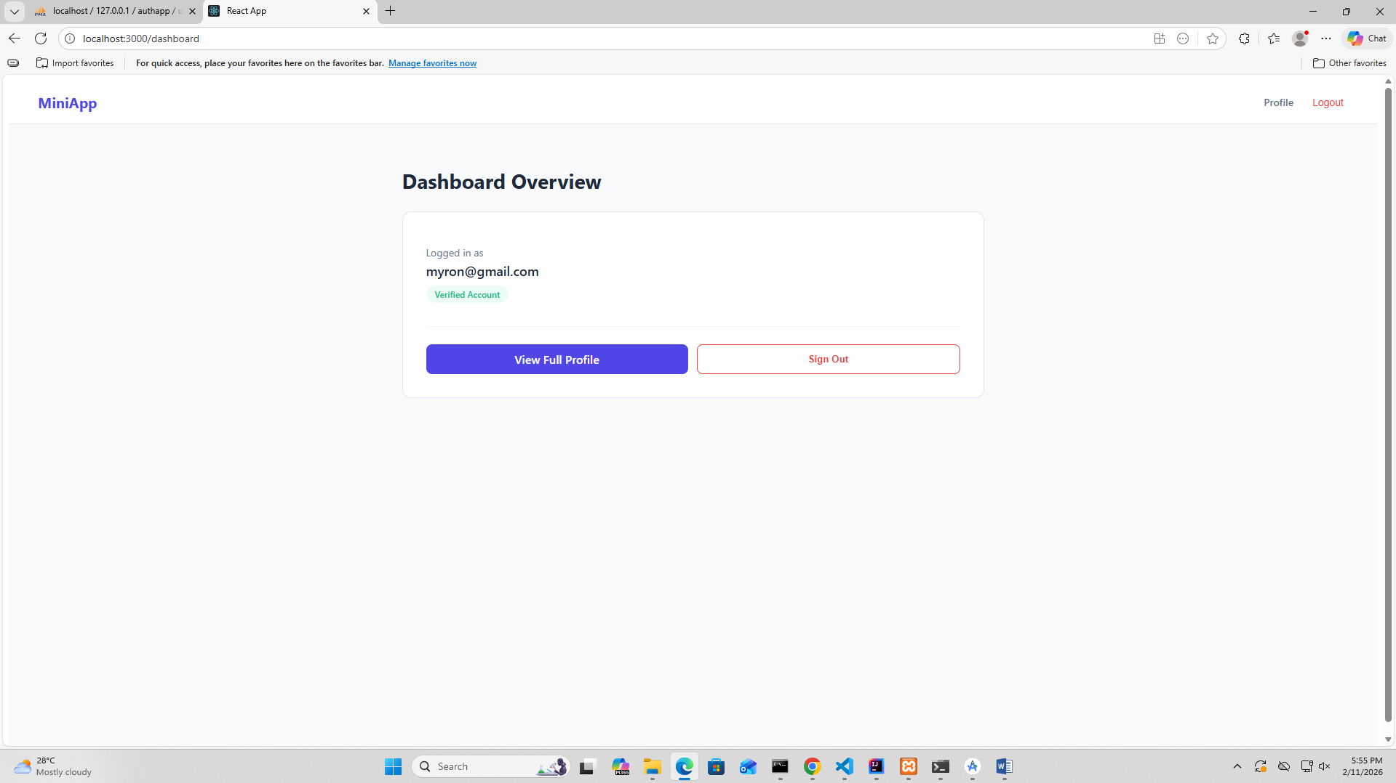

Profile
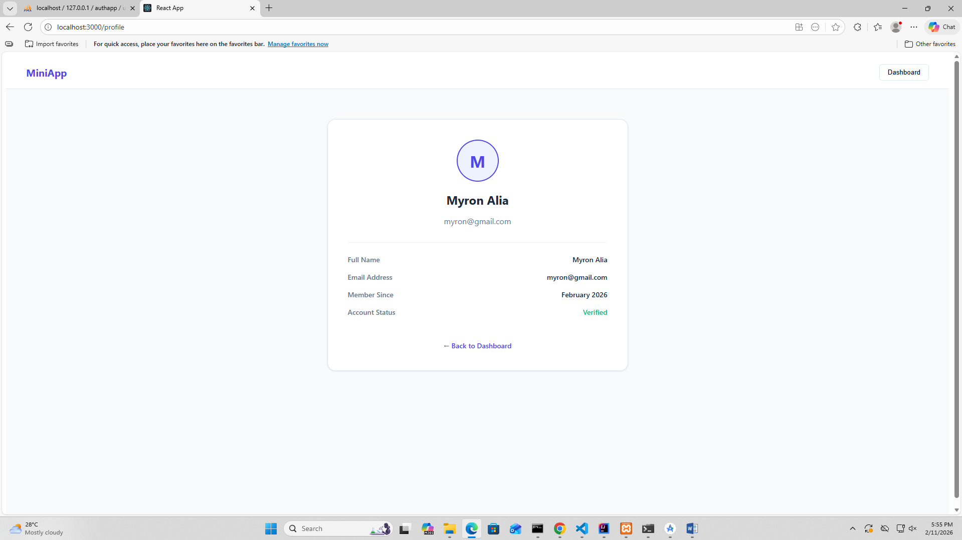

Logout
